GROUP MEMBERS:

Name | PRN
Aryan Unhale | B25CE1059
Ishita Yelne | B25CE1060
Vedadny Bukke | B25CE1061
Chaitanya Deshpande | B25CE1062

TOURISM DATA ANALYSIS REPORT

1. Research

Tourism is one of the fastest-growing industries and plays a key role in economic development, employment generation, and cultural exchange. In India, tourism is especially important due to its diverse geography, heritage sites, and cultural richness.

Key Research Findings:
- Tourism demand depends on:
  - Climate and season
  - Travel purpose (leisure, religious, business)
  - Accessibility and infrastructure
- Seasonal variation strongly affects tourist flow
- Domestic tourism is more stable than international tourism
- Data analytics helps in:
  - Identifying trends
  - Predicting peak seasons
  - Improving tourism planning

Dataset Used:
- Source: Kaggle
- Records: 10,000
- Locations: 25+ destinations
- Data includes:
  - Location, Month, Season
  - Visitor Type
  - Revenue
  - Transport Mode

References:
- World Tourism Organization (UNWTO): https://www.unwto.org
- Ministry of Tourism, India: https://tourism.gov.in
- Kaggle Tourism Dataset
- Tableau Documentation
- Microsoft Excel Documentation

2. Analysis
The dataset was analyzed using Excel and Tableau dashboards.

Domestic vs International Tourists:
- Domestic: ~51%
- International: ~49%
- Insight: Domestic tourism slightly dominates and forms the base of the industry

Monthly Revenue Trends:
- Revenue range: ₹20B – ₹25B
- Peak month: January
- Insight:
  - Winter season generates highest revenue
  - Due to holidays and favorable weather

Popular Destinations:
- High tourist locations:
  - Varanasi
  - Kerala
  - Rajasthan
- Insight:
  - Cultural and heritage sites attract more visitors

Seasonal Trends:
- High season:
  - Winter
  - Summer
- Low season:
  - Monsoon
- Insight:
  - Weather conditions directly impact tourism

Purpose of Travel:
- Most common:
  - Leisure
- Followed by:
  - Family trips
  - Religious tourism
  - Business travel
- Insight:
  - Majority travel for relaxation and experiences

Transport Analysis:
- Flights - Long-distance travel
- Trains - Medium-distance
- Cars/Bus - Short-distance
- Insight:
  - Transport choice depends on distance and accessibility

Global Tourist Distribution:
- Major countries:
  - USA
  - UK
  - Canada
  - Australia
- Insight:
  - India has strong international tourism presence

3. Ideate

Based on the analysis, the following ideas were proposed:

Tourism Improvement Ideas:
- Season-Based Marketing
  - Promote destinations based on seasonal demand
- Infrastructure Development
  - Improve facilities in high-traffic locations
- Personalized Travel Suggestions
  - Recommend destinations based on travel purpose
- Revenue Optimization
  - Focus marketing during peak months
  - Offer discounts in off-season
- Transport Improvements
  - Better connectivity for less popular destinations

4. Build
The project was implemented in multiple stages using different tools.
1)Data Cleaning using Excel:
The dataset was cleaned by removing duplicate records and handling missing values. The data was then organized and structured for analysis. Pivot tables were created to summarize and analyze trends.
2)Data Visualization using Tableau:
Interactive dashboards were created in Tableau, including charts for tourist arrivals, revenue trends, seasonal analysis, and global tourist distribution maps. These visualizations made it easier to identify patterns and insights.
3)Web Dashboard using React and Vite:
A web-based dashboard was developed to present the analysis in an interactive format. The dashboard includes charts, graphs, and key insights, providing a user-friendly interface for data presentation.

Data Preparation (Excel):
- Removed duplicates
- Handled missing values
- Organized dataset
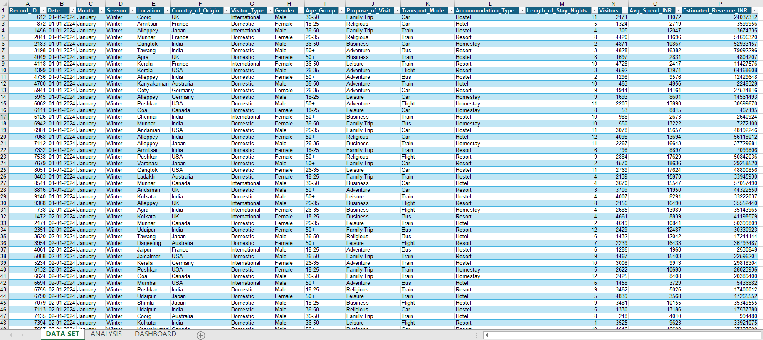
- Created pivot tables

Data Visualization (Tableau):
- Built dashboards including:arrivals

5. Outputs
- Excel Dashboard
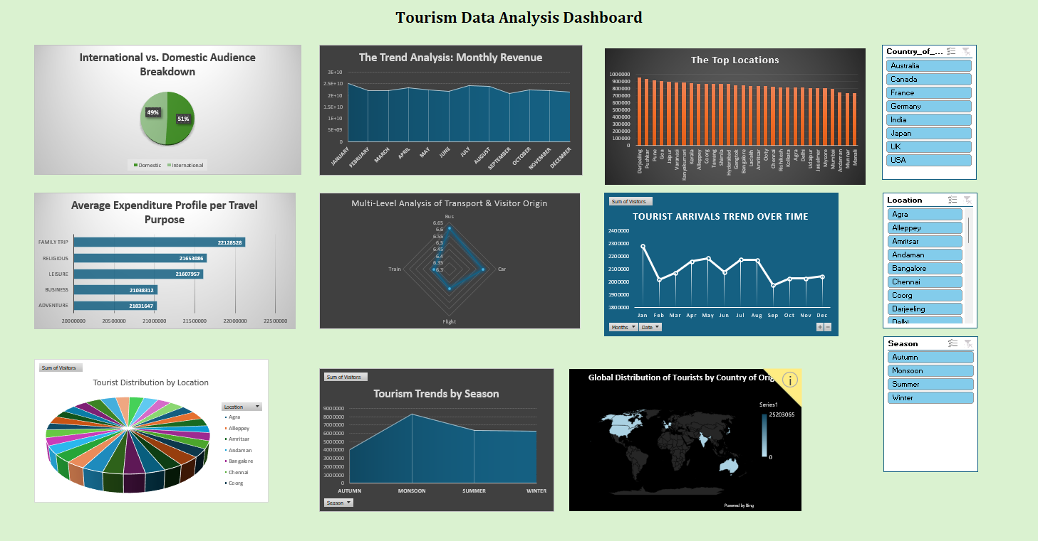
- Tableau Dashboard
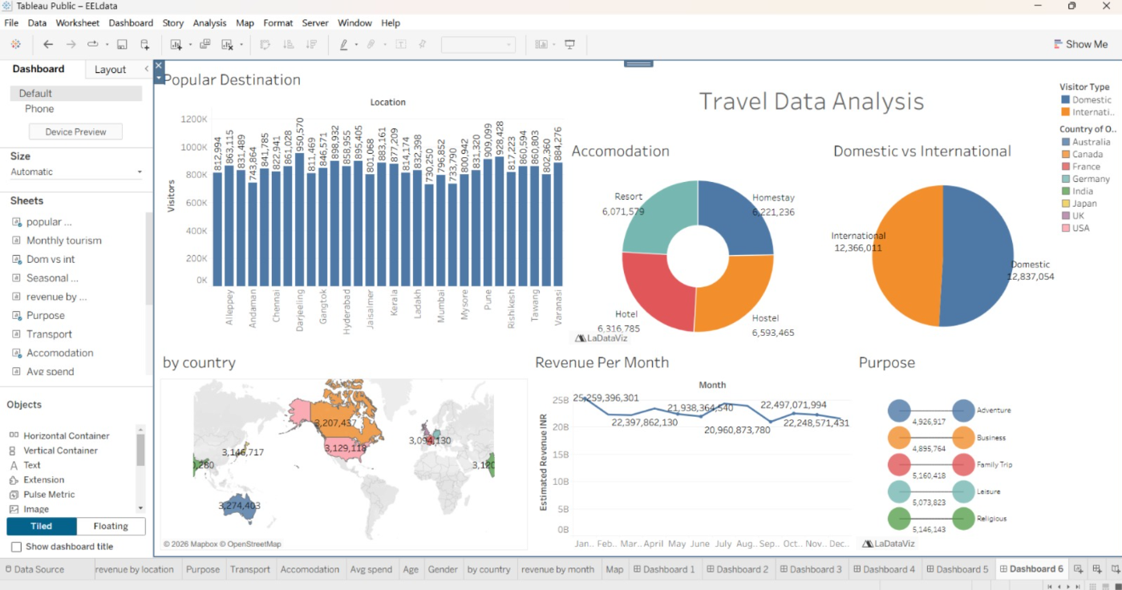

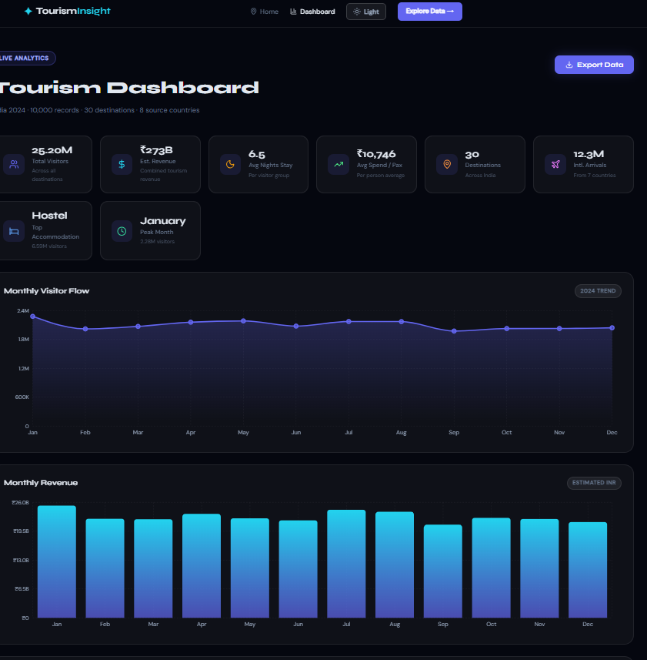
- Web Dashboard

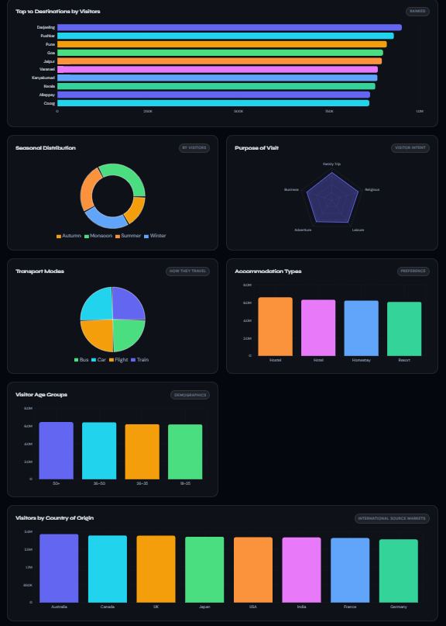

6) Implementation

7)Conclusion
This project demonstrates how raw tourism data can be transformed into meaningful insights using data analysis and visualization tools. It highlights the importance of understanding seasonal patterns, visitor behavior, and revenue trends in the tourism industry.
The use of Excel and Tableau made it easier to analyze and present complex data, while the web dashboard improved the overall presentation of the project. This project also helped in developing practical skills in data cleaning, analysis, and visualization.

